**STAMP ACT/AKTA STAMP**

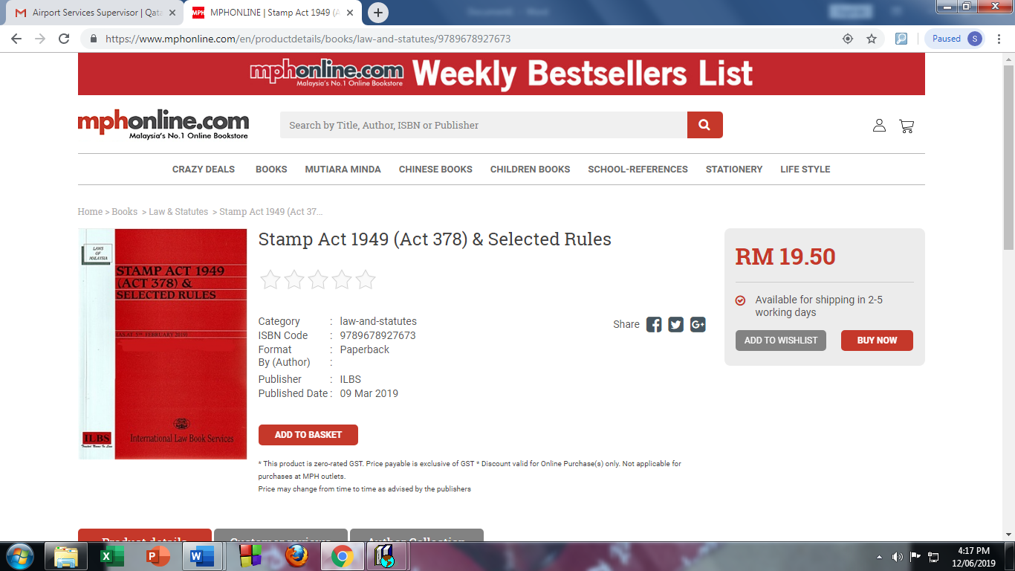

**TOWN AND COUNTRY PLANNING ACT/AKTA PERANCANGAN BANDAR**

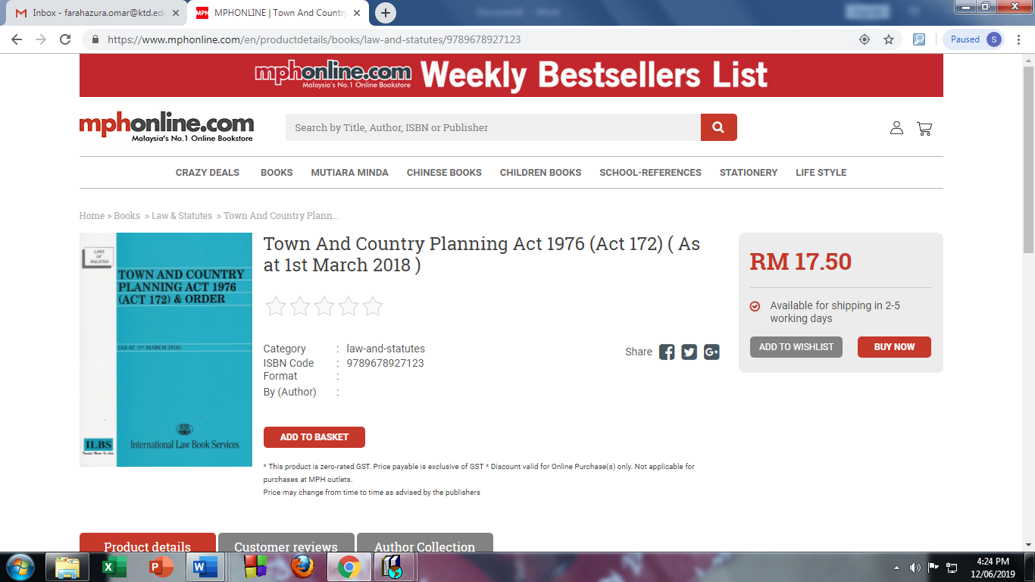



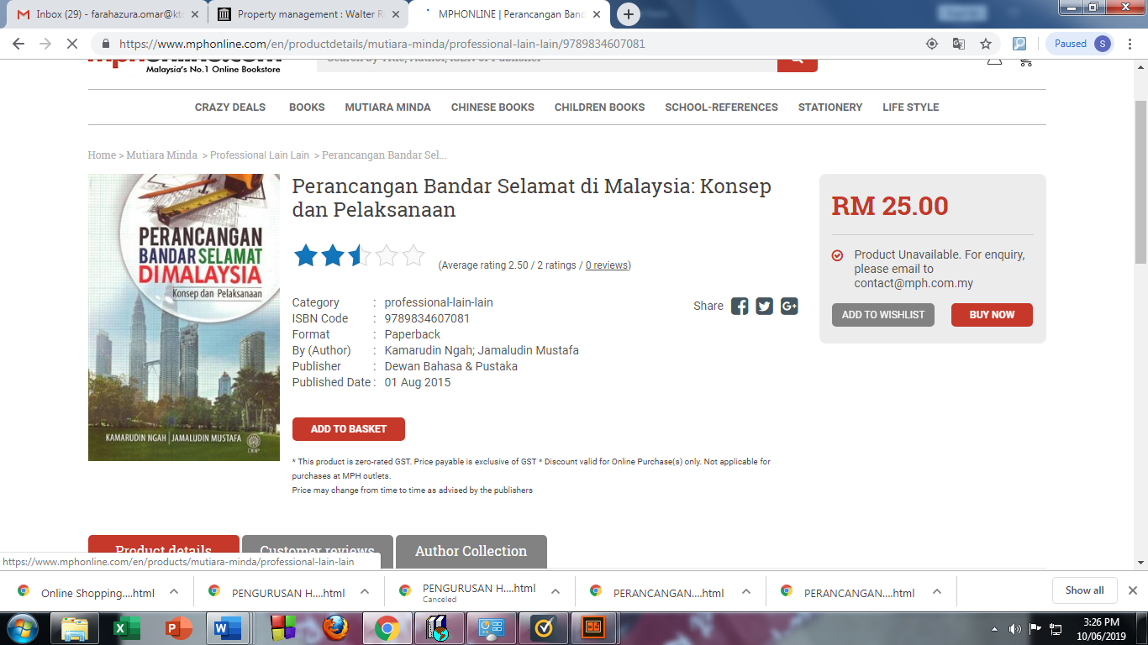

**REAL PROPERTY GAINS TAX ACT/AKTA CUKAI KEUNTUNGAN HARTA TANAH**

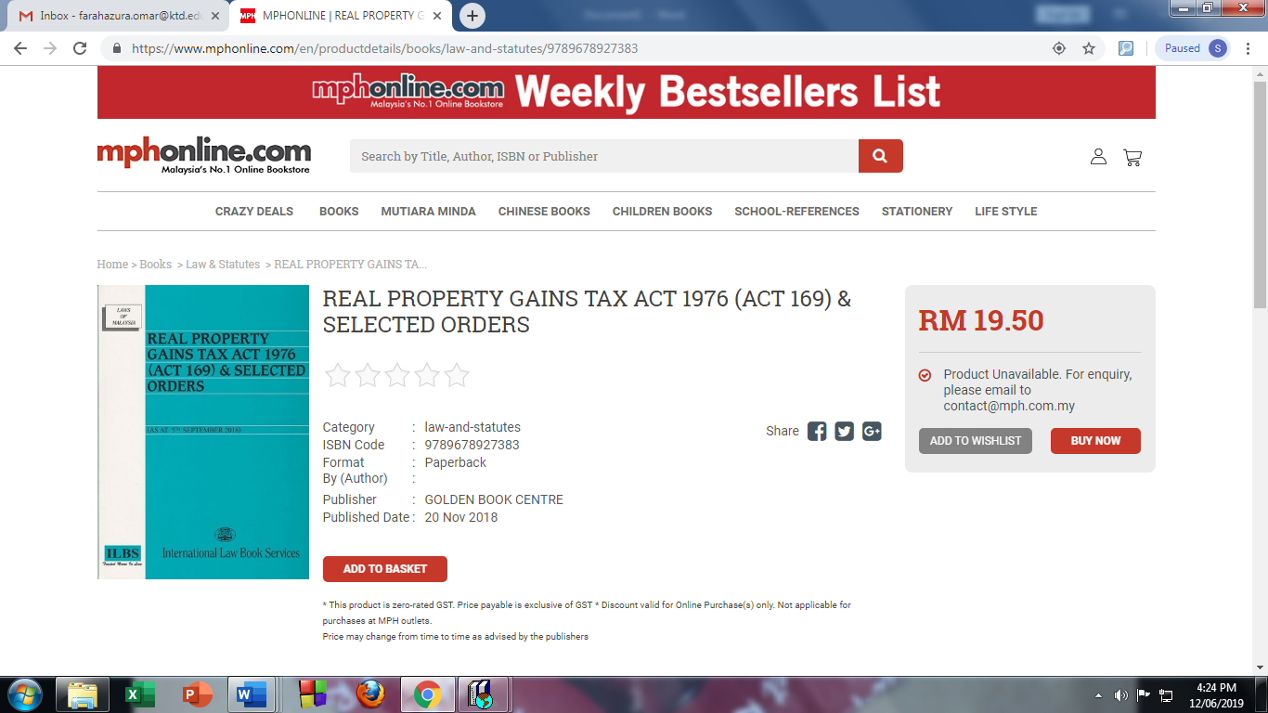



**LOCAL GOVERNMENT ACT/AKTA KERAJAAN TEMPATAN**

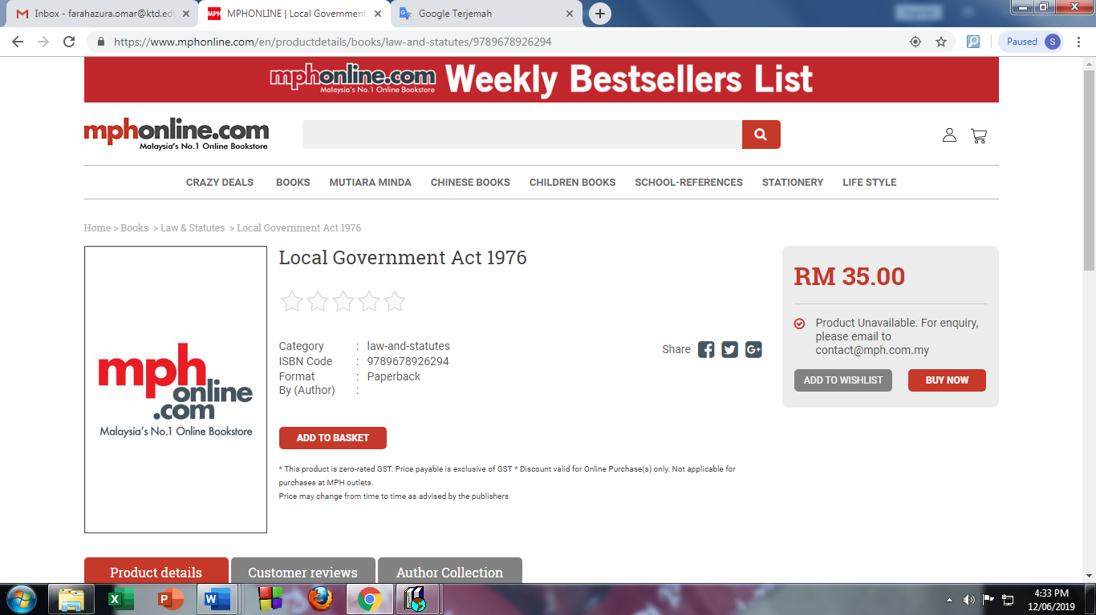





**AKTA KONTRAK/ CONTRACT ACT**



